NAME: RAJNANDINI KANDIKATLA

COLLEGE: NAGESH KARAJGI COLLEGE OF ENGINEERING AND TECHNOLOGY

BRANCH: COMPUTER SCIENCE &TECHNOLOGY

YEAR-SEM: 3-1

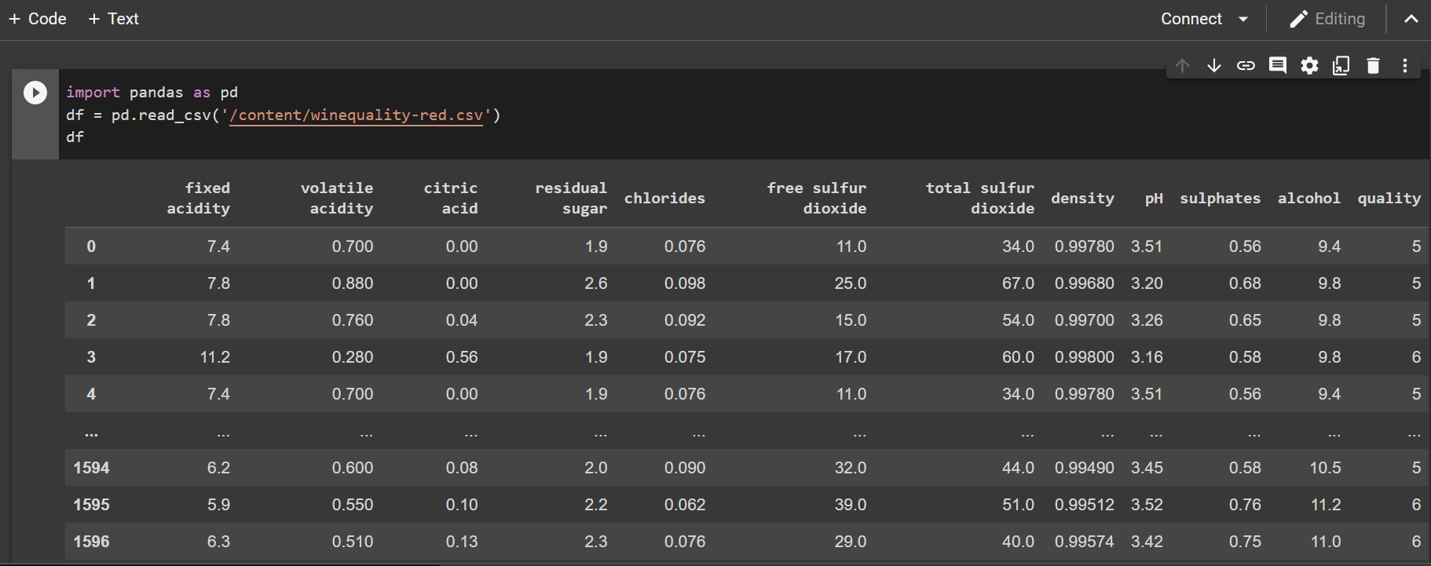

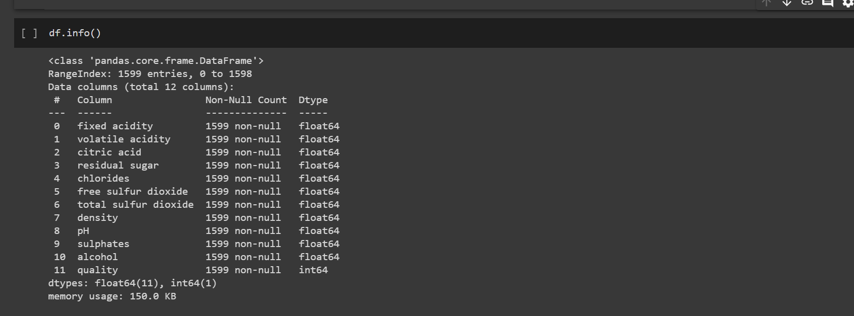

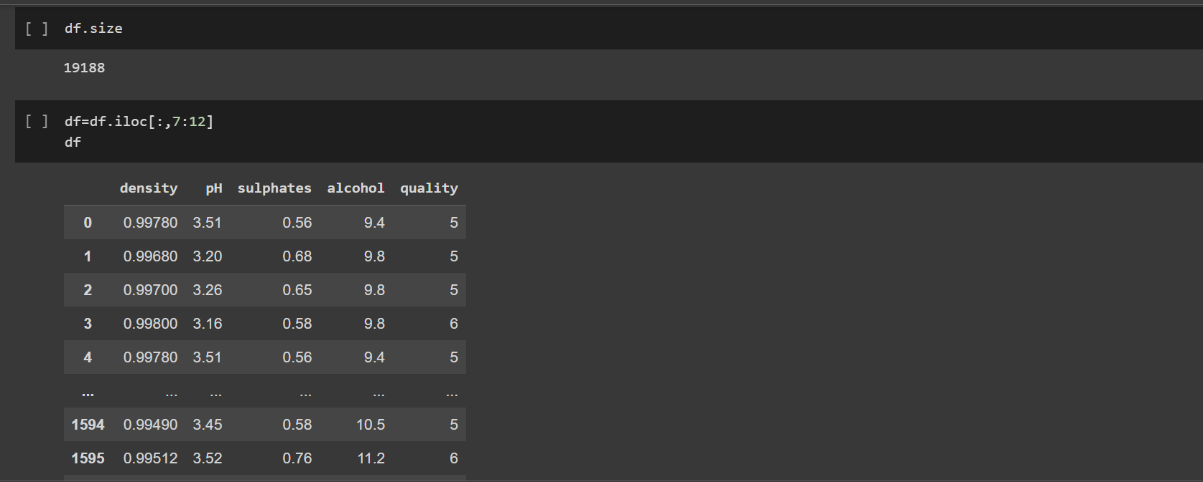

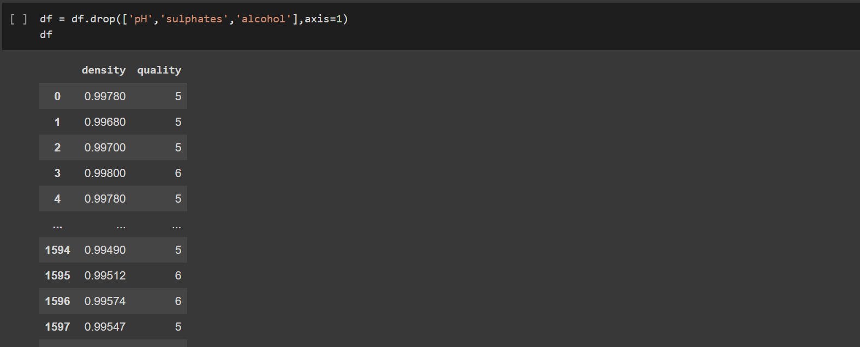

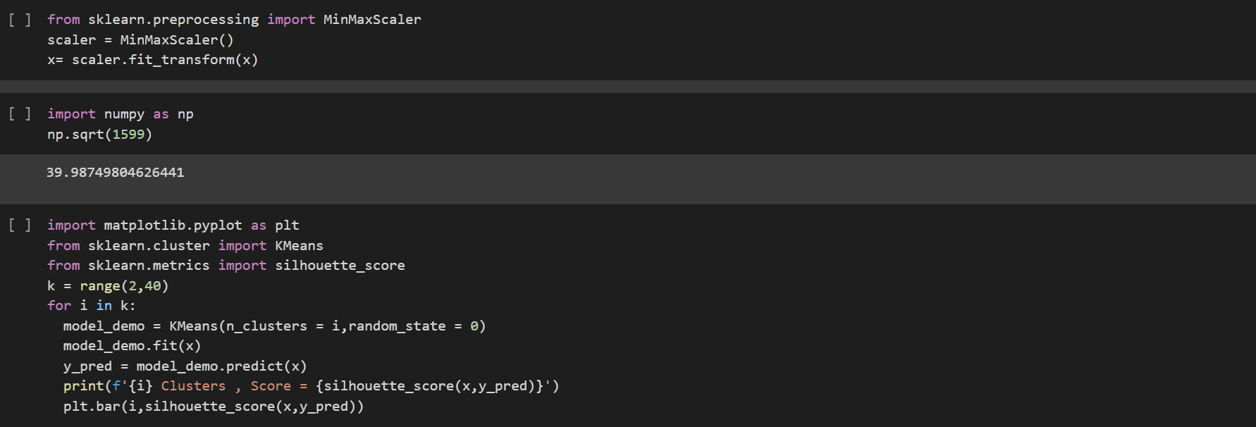

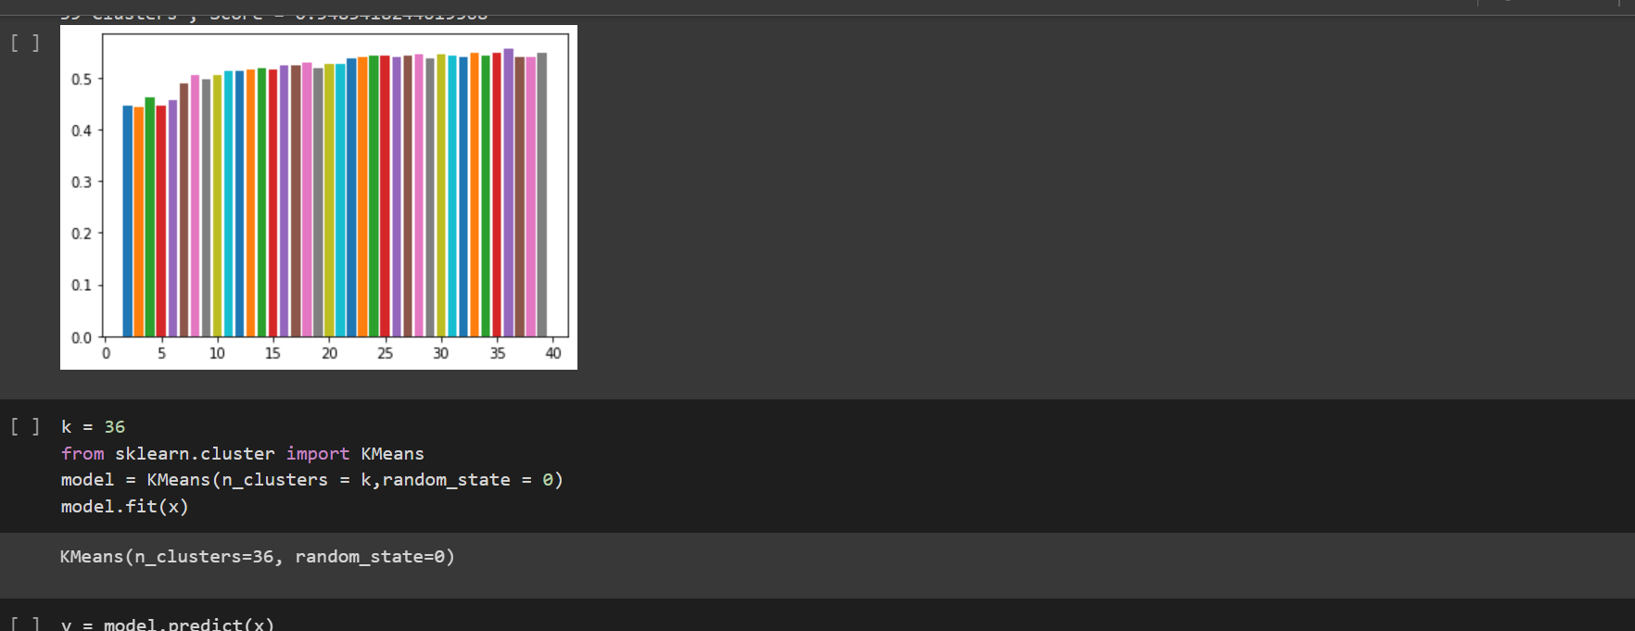

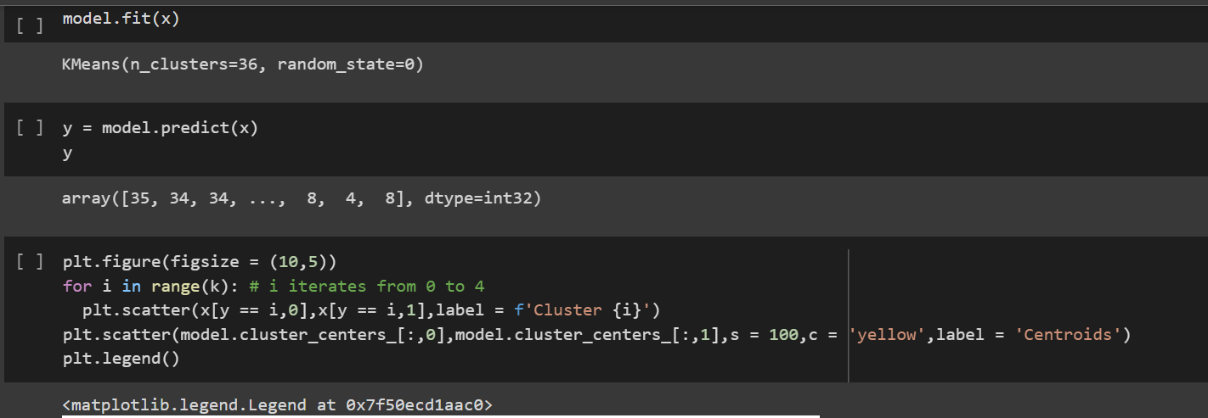

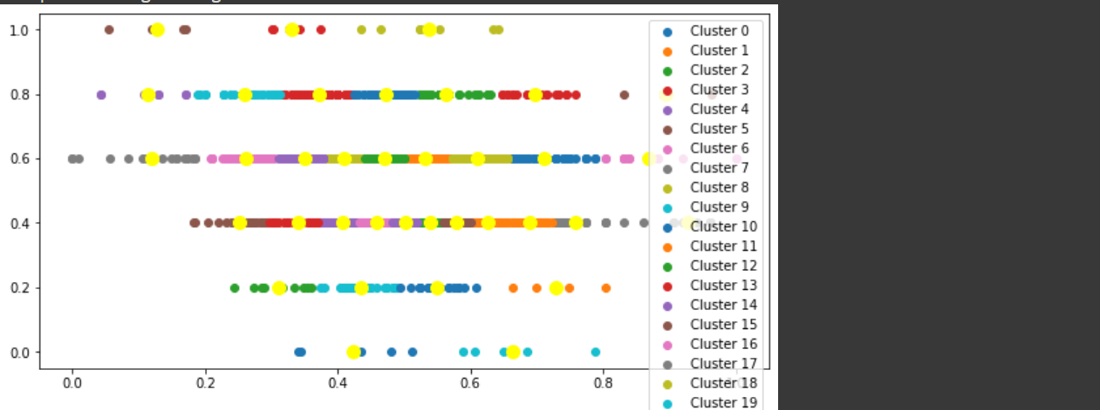

DATASET URL-<https://www.kaggle.com/datasets/uciml/red-wine-quality-cortez-et-al-2009>

GOOGLE COLLAB-<https://colab.research.google.com/drive/1Ygn5umaTl-7rhb51cuP_ewZVNXh4zhrr?usp=sharing>

GITHUB LINK-<https://github.com/Rajnandinik23/Majorproject2_rinex>